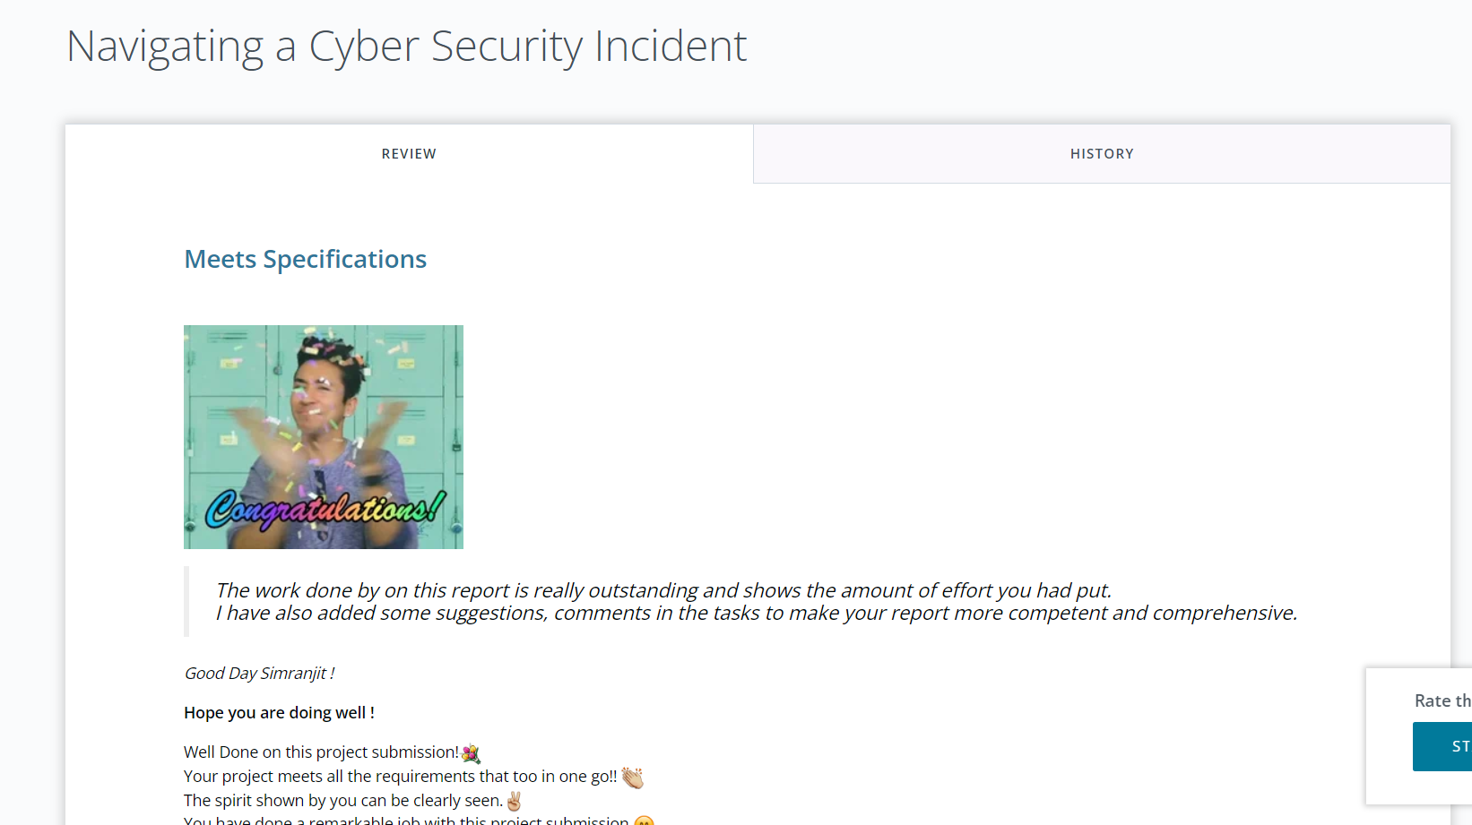

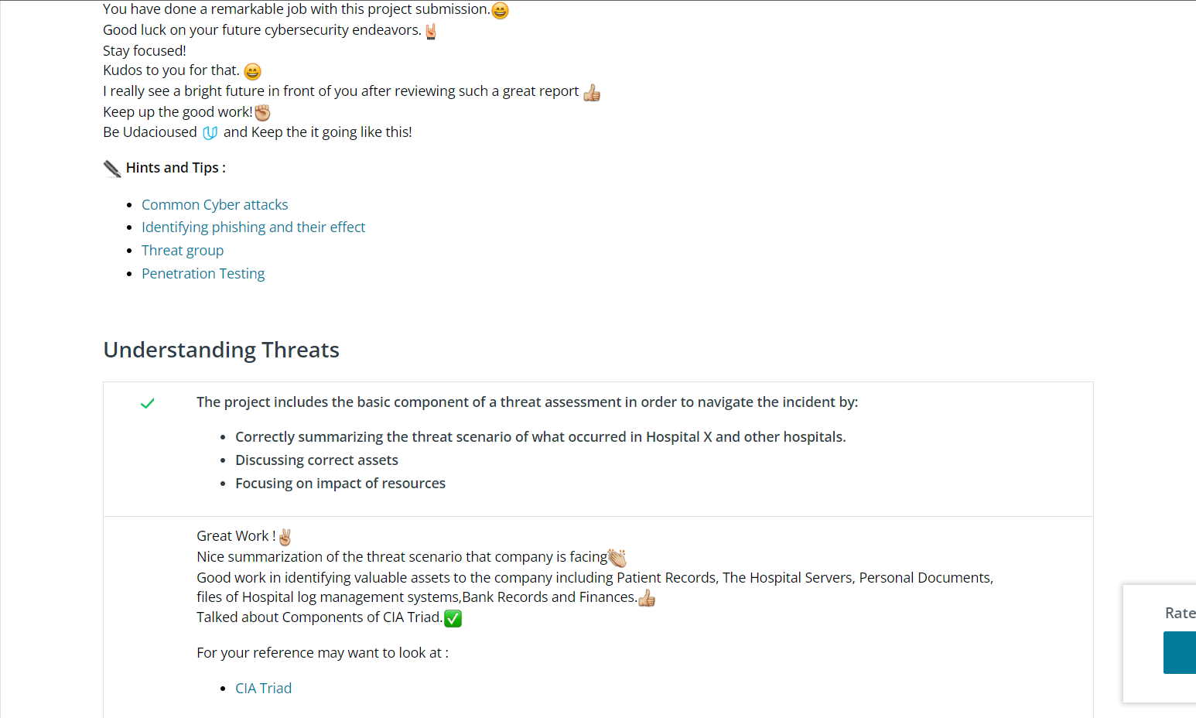

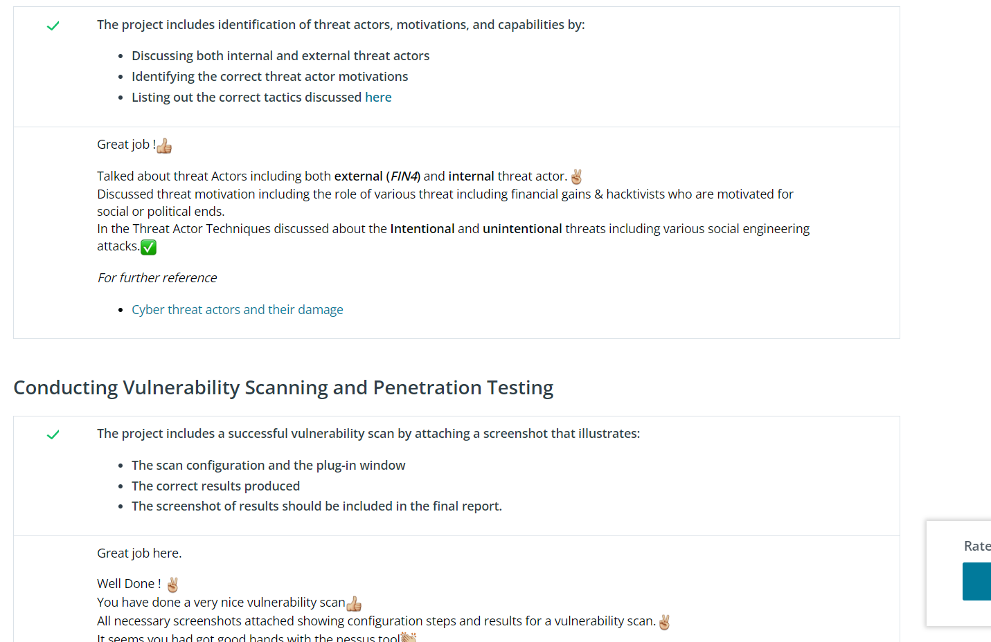

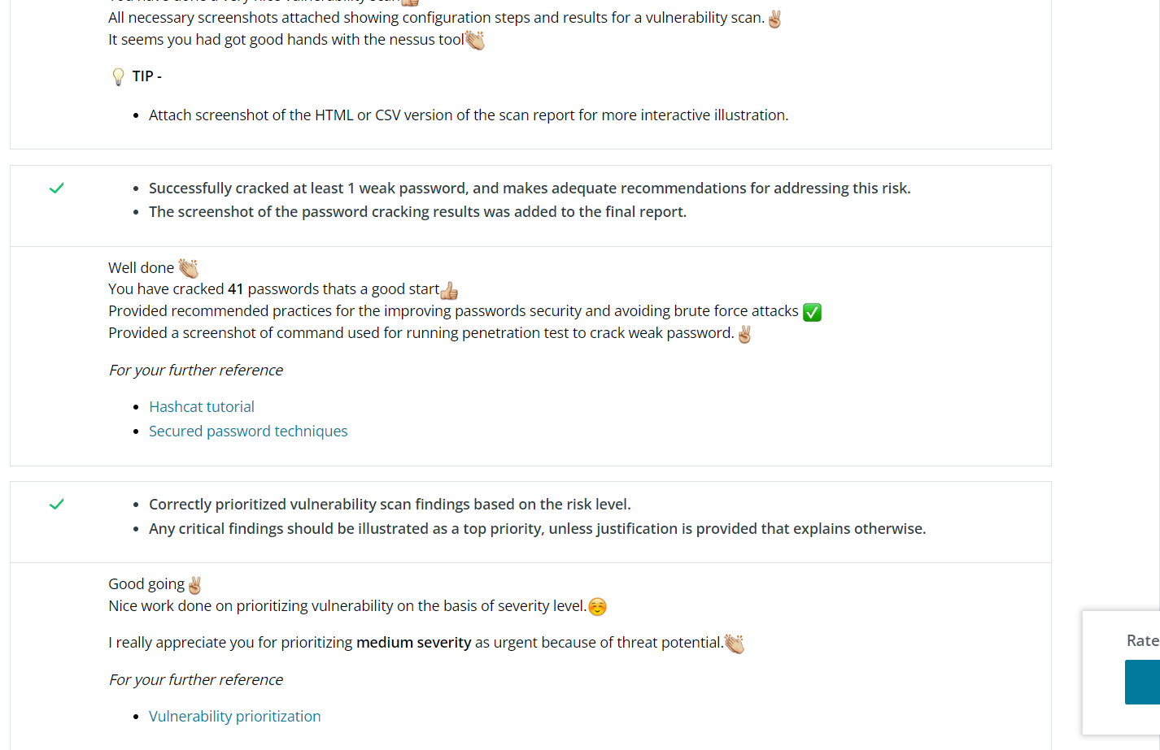

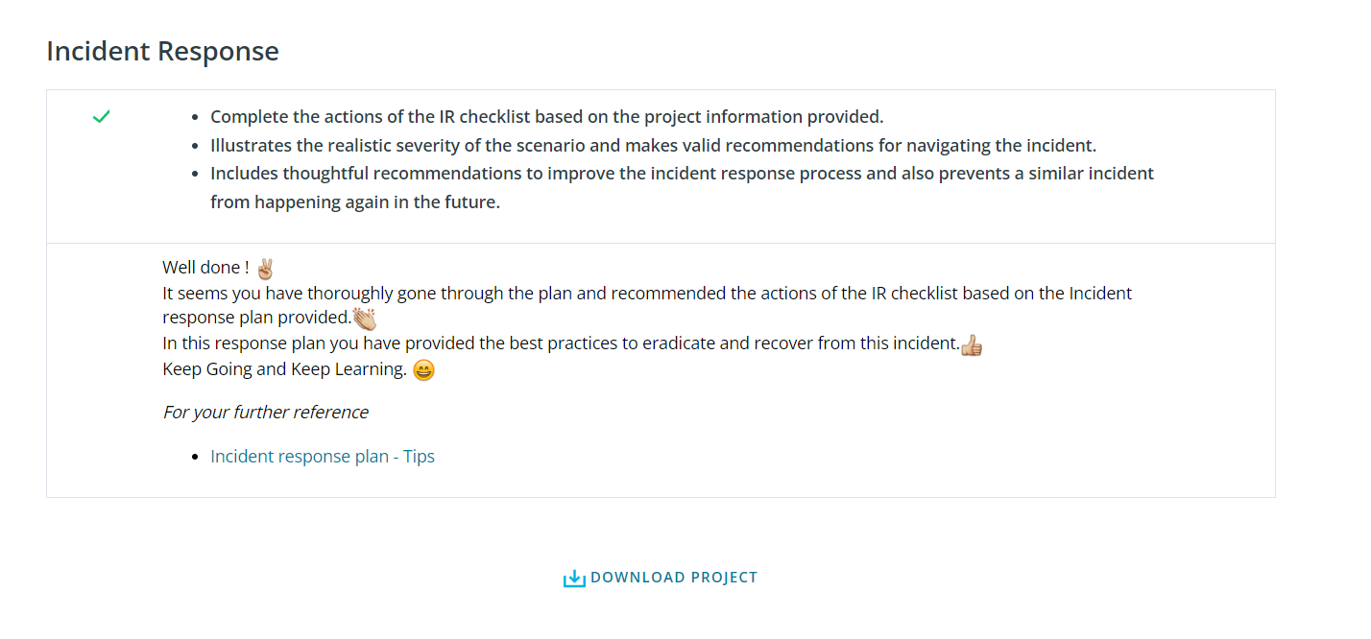

**Hints and Tips :**

* [Common Cyber attacks](https://www.cisco.com/c/en_in/products/security/common-cyberattacks.html)
* [Identifying phishing and their effect](https://www.cybsafe.com/community/blog/how-can-phishing-affect-a-business/)
* [Threat group](https://attack.mitre.org/groups/G0085/)
* [Penetration Testing](https://www.youtube.com/watch?v=rRUiRz_znLQ)

For your reference may want to look at :

* [CIA Triad](https://www.f5.com/labs/articles/education/what-is-the-cia-triad)

*For further reference*

* [Cyber threat actors and their damage](https://www.redlegg.com/blog/cyber-threat-actor-types)

*For your further reference*

* [Hashcat tutorial](https://laconicwolf.com/2018/09/29/hashcat-tutorial-the-basics-of-cracking-passwords-with-hashcat/)
* [Secured password techniques](https://blog.avast.com/strong-password-ideas)

*For your further reference*

* [Vulnerability prioritization](https://www.secureworks.com/blog/part-1-redefining-vulnerability-remediation-prioritization)

*For your further reference*

* [Incident response plan - Tips](https://digitalguardian.com/blog/incident-response-plan)